# **CIS225 Networking II** **Rafat Khandaker**

# **Unit 5 Lab 1**

# **NSLookup Tool**

**Purpose**: To demonstrate the usefulness of the NSLookup Utility. Students should know how to use this tool to verify the presence of a mail server and a DNS server on a network

**Prerequisites**: Your Windows client computer needs to be connected to the Internet.

**Lab Tasks:**

1. From the command prompt (start🡪run🡪cmd), enter Ipconfig /all. Take note the DNS server address: **_192.168.1.1_**

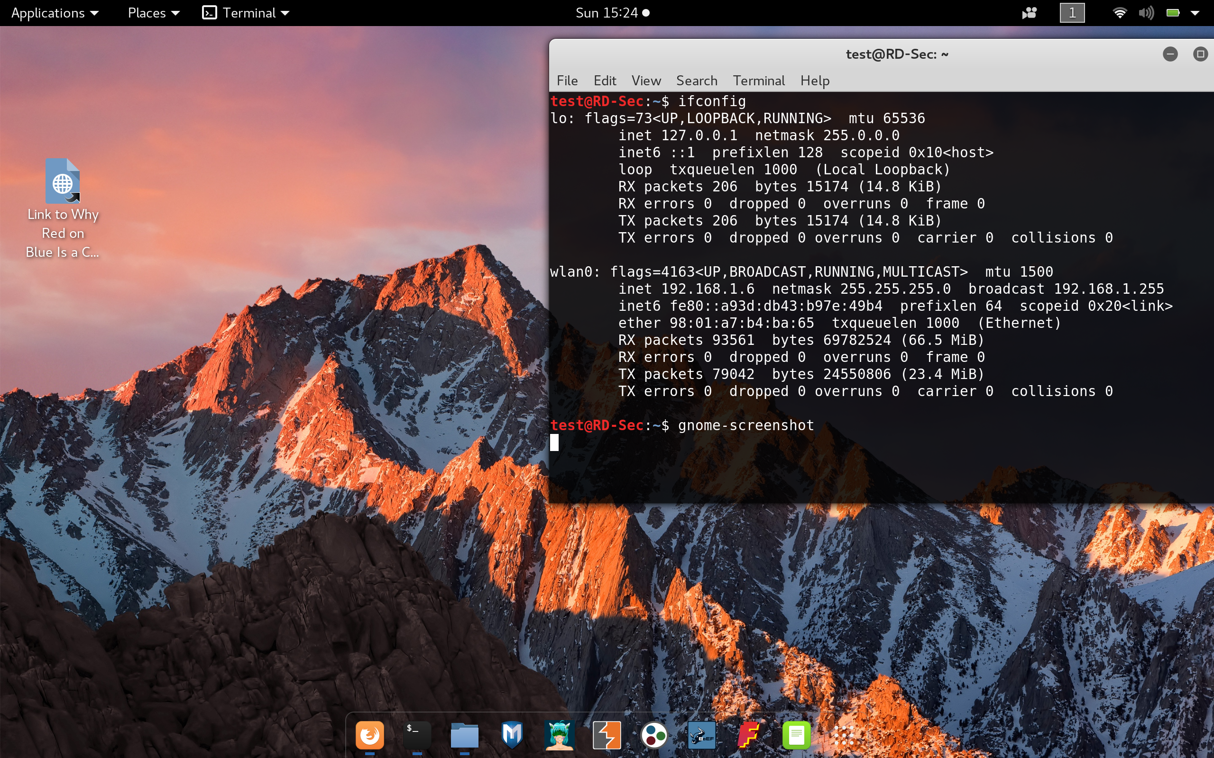

1. Type *nslookup* and press enter *(this places you into interactive mode)*
2. Type ecpi.net, press enter
3. Type yahoo.com, press enter

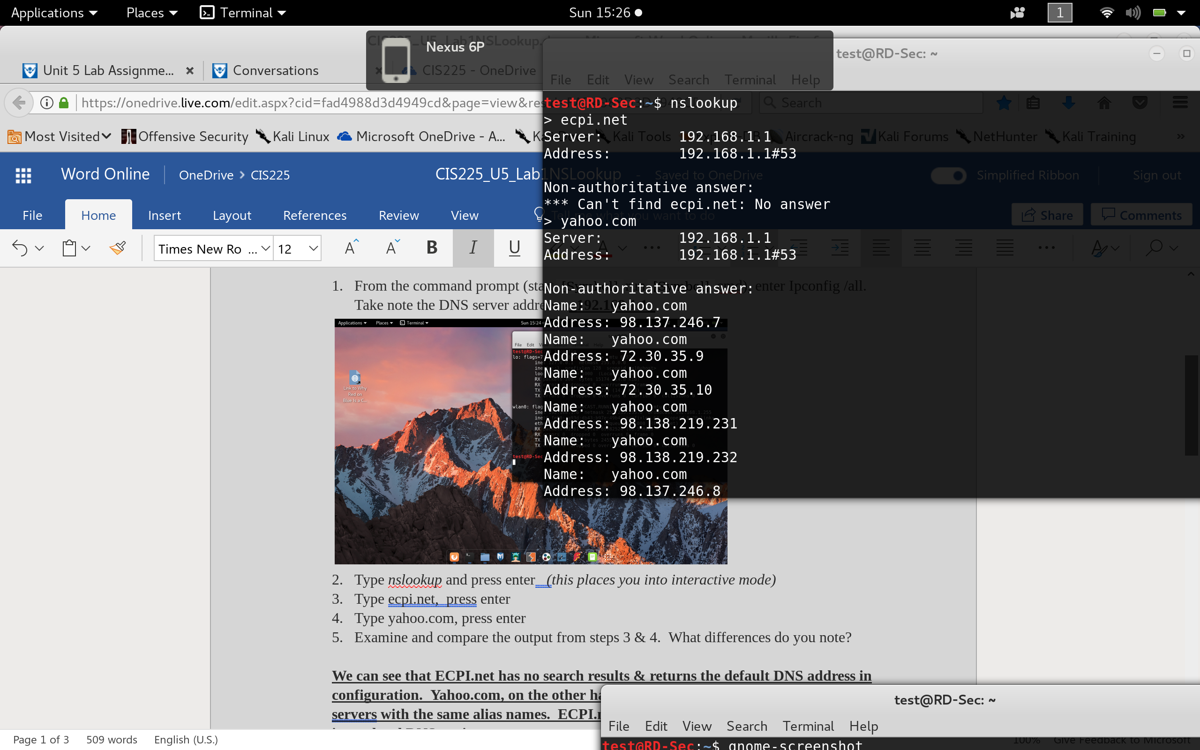

1. Examine and compare the output from steps 3 & 4. What differences do you note?

**We can see that ECPI.net has no search results & returns the default DNS address in configuration. Yahoo.com, on the other hand, has multiple DNS listing addresses & servers with the same alias names. ECPI.net does not have its DNS name registered in my local DNS settings.**

1. How would knowing the name server be helpful?

**Knowing the DNS name is good for accessing a site without having to remember it’s multiple IP addresses for each server that is hosting the site. Also, DNS allows redirection & load balancing protocols to a site’s associated server farm. Another advantage of using DNS protocol, is multiple servers in a single farm can share a single SSL certificate.**

1. Type *set type=mx* and press return, then type *www.ecpi.net*. What information does this provide?

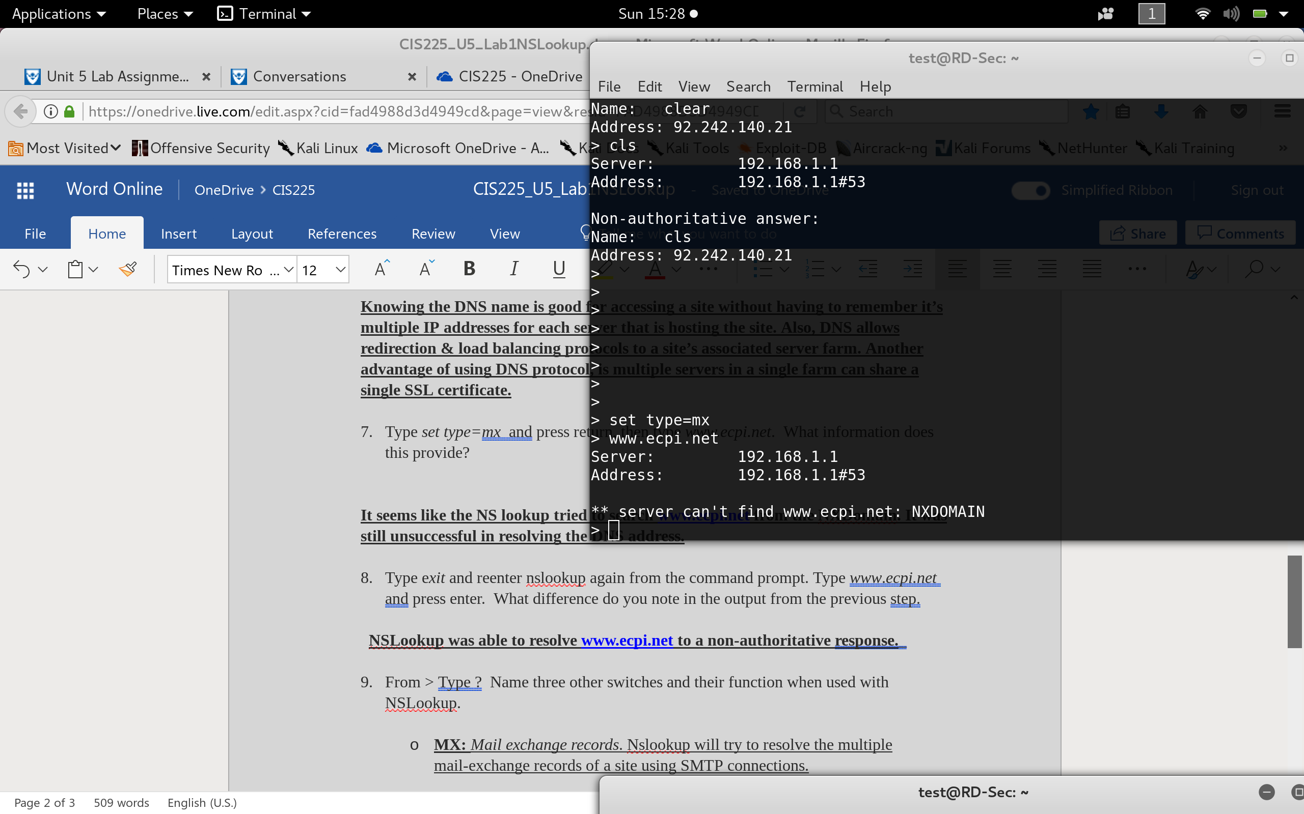

**It seems like the NS lookup tried to search** [**www.ecpi.net**](http://www.ecpi.net) **from the NXDomain. It was still unsuccessful in resolving the DNS address.**

1. Type e*xit* and reenter nslookup again from the command prompt. Type *www*.*ecpi.net* and press enter. What difference do you note in the output from the previous step.

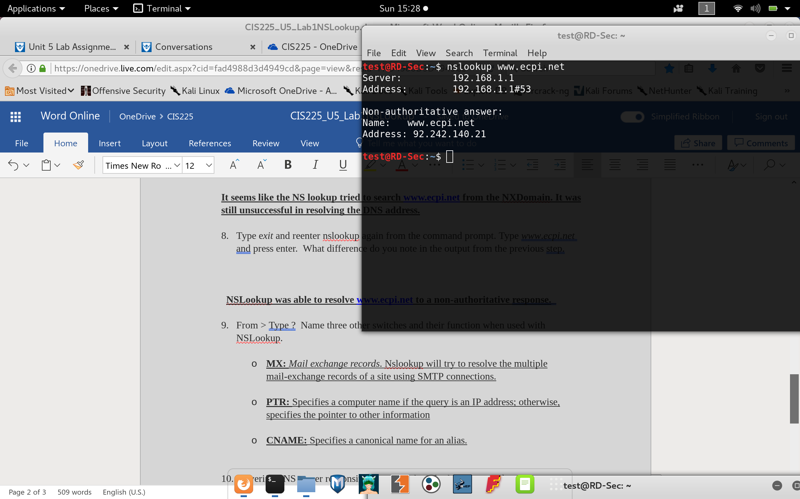

**NSLookup was able to resolve** [**www.ecpi.net**](http://www.ecpi.net) **to a non-authoritative response.**_

1. From > Type ? Name three other switches and their function when used with NSLookup.
   * **MX:** *Mail exchange records*. Nslookup will try to resolve the multiple mail-exchange records of a site using SMTP connections.
   * **PTR:** Specifies a computer name if the query is an IP address; otherwise, specifies the pointer to other information
   * **CNAME:** Specifies a canonical name for an alias.
2. To verify DNS server responsiveness using the nslookup command
3. At a command prompt, type: *nslookup* {server_ip_address} *127.0.0.1* where server_ip_address is the IP address of the DNS server at which you are verifying its responsiveness. For example, if the IP address of your DNS server is 10.90.0.6, you would type: C:\**nslookup 10.90.0.6**

**1.0.0.127.in-addr.arpa name = localhost.**

**Authoritative answers can be found from:**

1. If the server is responding, the name "localhost" is returned. If the server does not respond, you would continue troubleshooting the DNS server.

**SET TYPE= PTR**

1. Using the command that you just used would place you in what nslookup mode?

_____**SET TYPE=PTR**__This will enable information of single computer information from IP address query in dns record, My DNS server does not have a DNS name associated with it’s IP address so it cannot reverse lookup my DNS information through IP address.__

